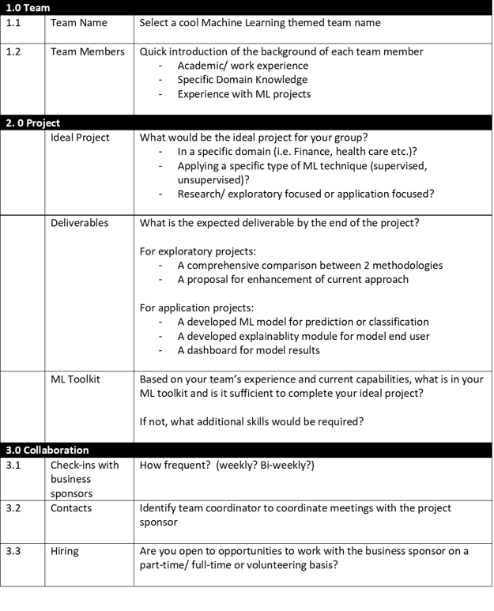

Team Name: Powahowa

Team Members:

* Alex Fung
* Patrick Osborne
* Tony Lee
* Viswesh Krishnamurthy

Ideal Project:

* Patrick: workforce/HR analysis, marketing
* Vis: manufacturing/supply chain/transportation
* Alex: academic research/public data analysis
* Tony: FinTech/edge computing

ML Toolkit:

* Extensive experience with audio analysis/machine learning numerical/vector and image-based features, Cloud/GPU accelerated
* Neural networks for image recognition
* Google Cloud services and implementation
* GeoSpatial modelling
* UX Design and interactive results presentation/app development
* Business and proposal writing/data science in clear language
* NLP sentiment analysis
* NLP text classification

Team Contacts:

* Patrick Osborne and Viswesh Krishnamurthy (back up for each other when unavailable)

Hiring:

* Open to opportunities